DBMS ASSIGNMENT 3
Local Case Study – Kirana Store
Unit 1 – DBMS Fundamentals
Topic: Databases & DBMS Components
Practical Implementation: PostgreSQL
Student Name | Sasanka Sekhar Kundu
Assignment | DBMS Assignment 3 – Local Case Study
Case Study | Kirana Store
Database System | PostgreSQL
Database Name | dbms_assignment_3

1. Introduction
This case study examines how a small kirana store can use a relational Database Management System (DBMS) to manage customers, suppliers, products, inventory and sales. The practical implementation was completed using PostgreSQL. The database dbms_assignment_3 contains five related tables: customers, suppliers, products, sales and sale_items.

2. Objectives
- Understand the role of a DBMS in a small local business.
- Design a simple relational database for store operations.
- Create tables using primary keys and foreign-key relationships.
- Perform insertion, updating, filtering, JOIN and aggregation operations.
- Demonstrate transaction processing using COMMIT and ROLLBACK.
- Relate PostgreSQL operations to major DBMS components.

3. Problem Statement
A kirana store must maintain product stock, supplier information, customer details and sales records. If these records are kept only in notebooks or separate spreadsheets, duplicate records, inconsistent stock values, difficult searches, weak access control and poor backup/recovery can occur. A relational DBMS provides structured storage, relationships, controlled updates and transaction management.

4. Relational Database Design
Table | Purpose | Primary Key | Foreign Key
customers | Customer details | customer_id | —
suppliers | Supplier details | supplier_id | —
products | Inventory and prices | product_id | supplier_id → suppliers
sales | Sales header records | sale_id | customer_id → customers
sale_items | Products within each sale | sale_item_id | sale_id → sales; product_id → products

5. PostgreSQL Implementation
The PostgreSQL database was successfully created and populated. The terminal evidence verifies five tables under the public schema. The implementation contains 3 suppliers, 3 customers, 6 products, 1 sale and 3 sale items.

6. SQL Operations Demonstrated
DDL – Table Creation: CREATE TABLE was used for the five relational tables.
DML – Data Insertion: INSERT statements added suppliers, customers, products, sales and sale items.
UPDATE: The sales record was updated from ₹100.00 to ₹80.00.
Filtering: A WHERE condition identified products with quantity below 25.
JOIN: JOIN queries combined customer, sales, sale_items, products and suppliers.
Aggregation: COUNT and SUM calculated total sales and revenue.
Transactions: BEGIN, COMMIT and ROLLBACK demonstrated transaction control.

7. Transaction Management Demonstration
A transaction reduced Parle-G Biscuits stock by 2 units, changing the quantity from 50 to 48, and the change was committed. A second transaction temporarily reduced Tata Salt from 30 to 25; ROLLBACK restored it to 30. This demonstrates how a DBMS preserves consistency when an operation is cancelled.

8. DBMS Component Mapping
DBMS Component | Role | Kirana Store Example
Query Processor | Interprets and executes SQL queries. | Owner searches inventory or generates reports.
Storage Manager | Manages persistent database storage. | Maintains customer, supplier, product and sales records.
Buffer Manager | Moves database pages between disk and memory. | Frequently accessed inventory/sales data can be served efficiently.
Transaction Manager | Controls transactions and consistency. | COMMIT confirms a stock update; ROLLBACK cancels an incorrect update.
DDL/DML Interpreter | Processes schema and data commands. | CREATE TABLE defines the schema; INSERT/UPDATE modify records.
Authorization/Security Subsystem | Controls access and modification privileges. | Owner/manager can have update privileges while staff can have limited access.

9. Benefits of the Proposed DBMS
- Reduced data redundancy through separate related tables.
- Improved consistency using primary and foreign keys.
- Faster searching and reporting using SQL and JOINs.
- Better inventory visibility through product quantities.
- Transaction safety through COMMIT and ROLLBACK.
- Controlled access through users and privileges.
- Better backup and recovery possibilities.
- Scalability as products, customers and sales increase.

10. Practical Results
The final complete sale report shows Priya Sharma purchased 2 Parle-G Biscuits, 1 Amul Milk and 2 Maggi Noodles. Their item totals are ₹20.00, ₹30.00 and ₹30.00, giving a total of ₹80.00. The low-stock query identified Amul Milk (20 units) and Fortune Oil (15 units).

11. Interview Notes / Field Study Annexure
The assignment requires a genuine 15–20 minute interview with a local small-business owner. The fields below should be completed from the actual interview. The PostgreSQL records in this report are practical demonstration data and should not be presented as the owner's actual statements unless they were collected during the interview.
Interview Item | Actual Interview Record
Business type / name | To be filled from actual interview.
Interviewee role | To be filled from actual interview.
Date and duration | To be filled from actual interview.
Current record-keeping method | To be filled from actual interview.
Information stored | To be filled from actual interview.
Who accesses/updates records | To be filled from actual interview.
Common problems/corrections | To be filled from actual interview.
Backup method | To be filled from actual interview.
Security/access concerns | To be filled from actual interview.
How a DBMS could improve the workflow | To be filled from actual interview.

12. Hand-Drawn DBMS Component Diagram
Draw the required diagram on paper using this flow: Store Owner / Staff → SQL/Application Interface → DBMS → Database Storage. Inside the DBMS box, include Query Processor, DDL/DML Interpreter, Authorization/Security Subsystem, Transaction Manager, Storage Manager and Buffer Manager. Add arrows showing requests moving toward storage and results returning to the user.

13. Conclusion
This case study demonstrates how PostgreSQL can organize a kirana store's customers, suppliers, inventory and sales using a relational structure. The practical work demonstrates DDL, DML, filtering, JOINs, aggregation and transaction management. The proposed DBMS improves consistency, reporting, transaction safety and controlled access compared with informal record keeping.

14. PostgreSQL Execution Screenshots
Database creation and PostgreSQL setup.
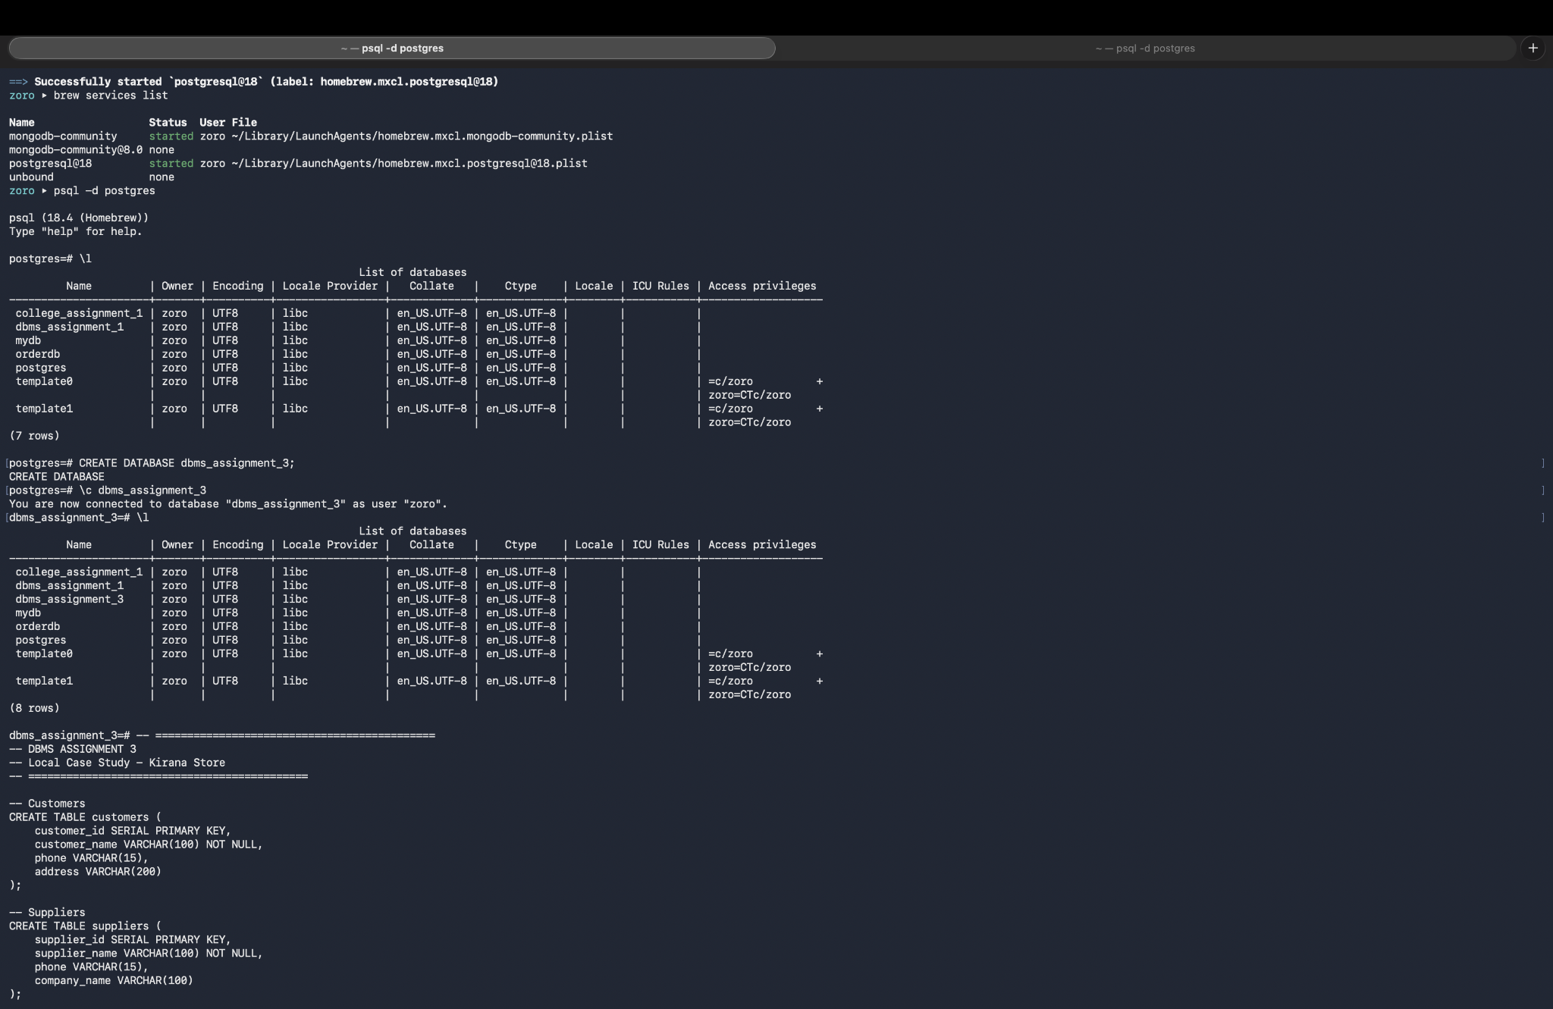
Table creation and verification using \dt.
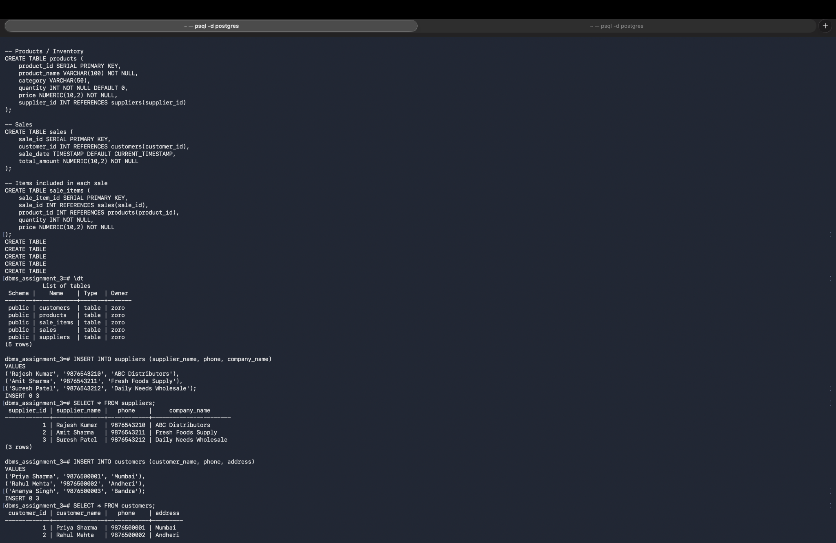
Supplier and customer data insertion and verification.
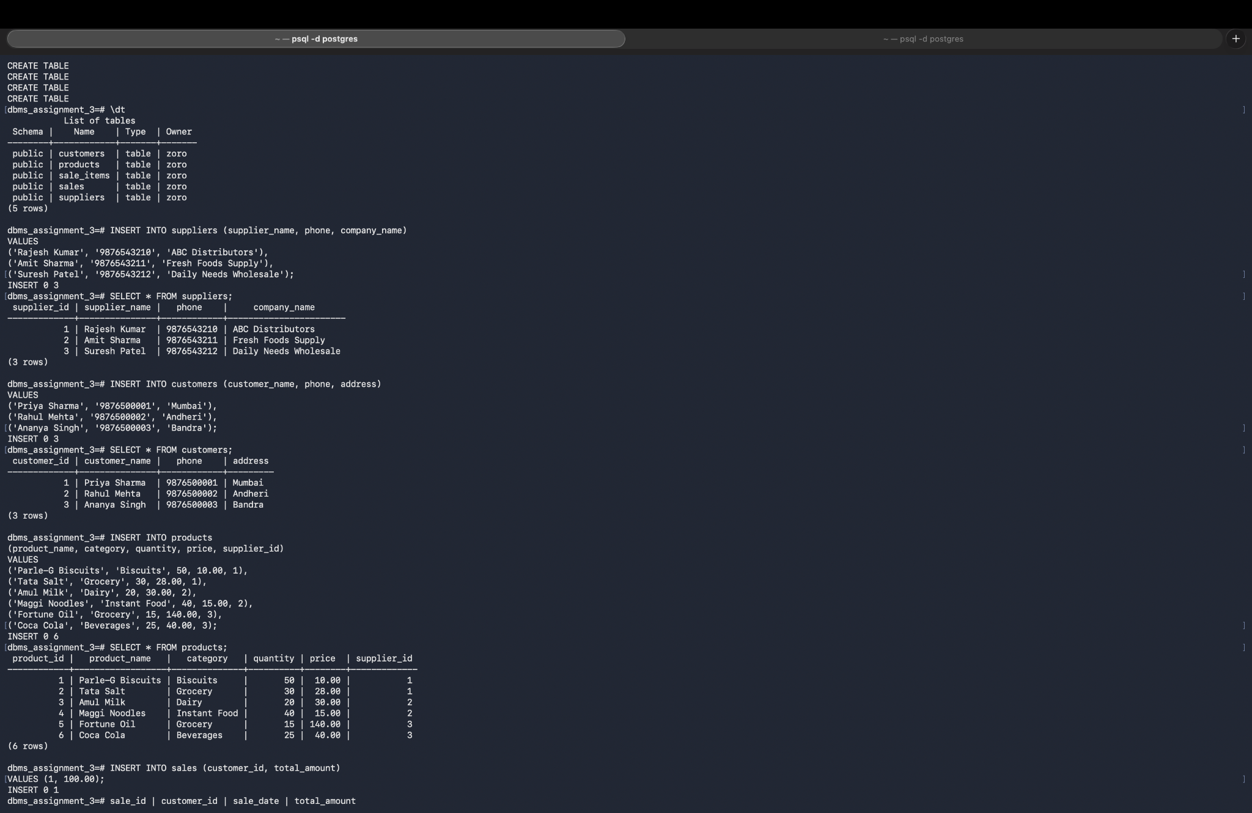
Product inventory and sales transaction.
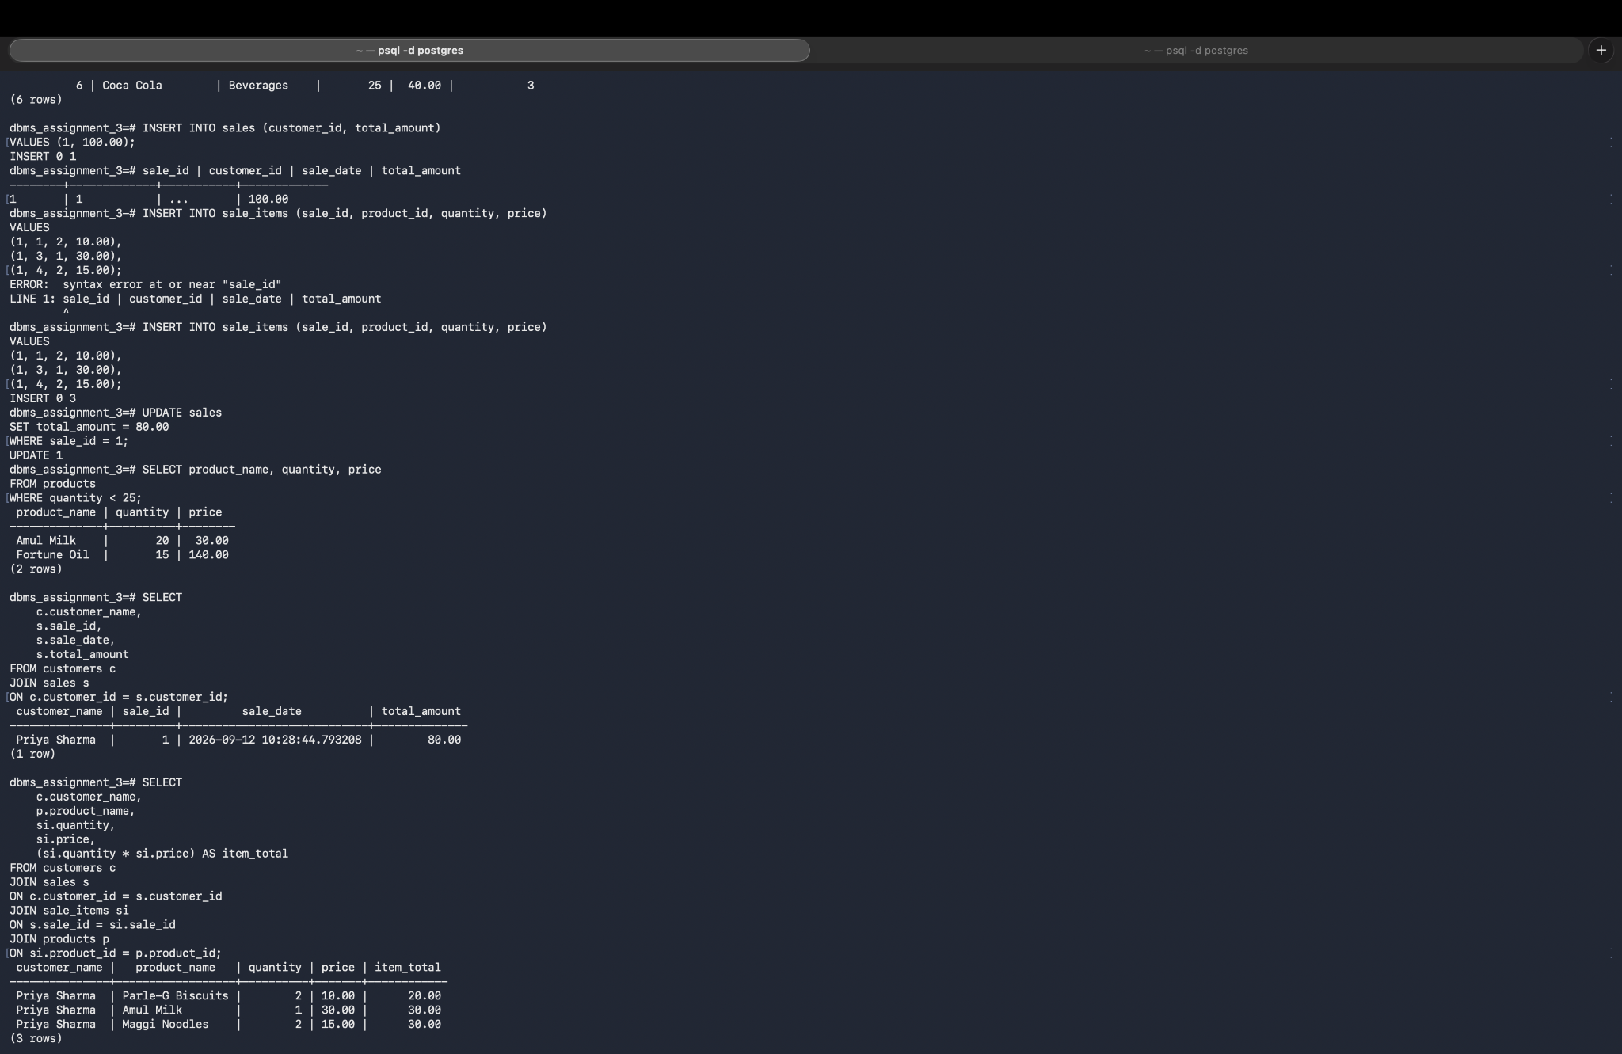
JOIN queries and sales details.
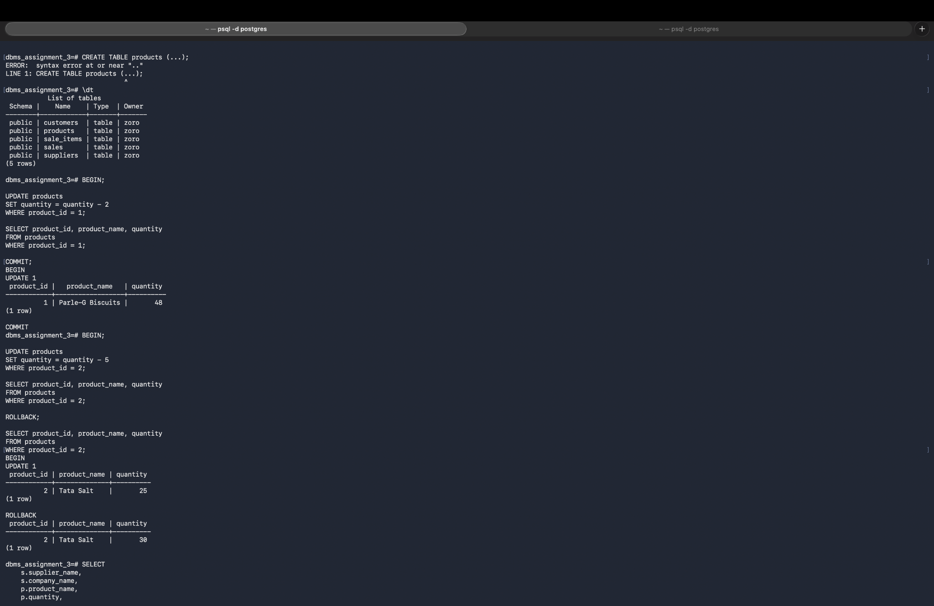
Transaction, aggregation, JOIN and final sale report.
